How to access the on-line textbook / Students
1. Go to this website--- Connected.mcgraw-hill.com
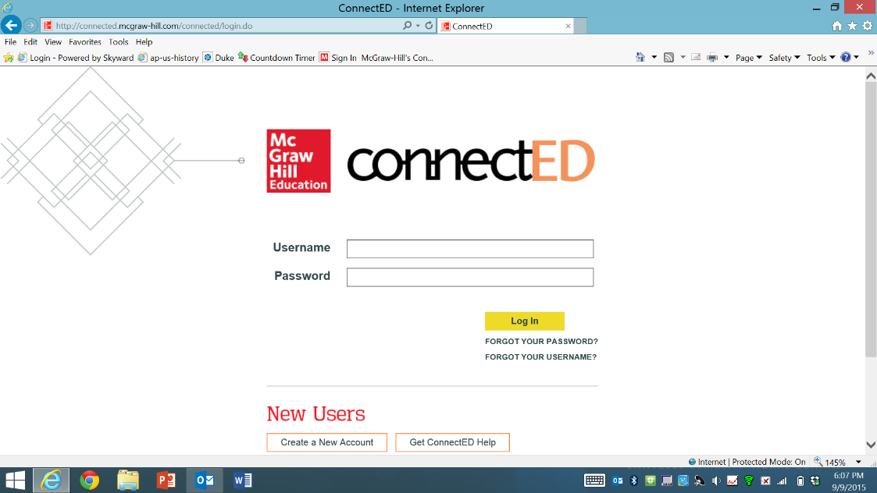
2. type in your user name (it must be in all capital letters)
Your SBISD username plus
@SPRINGBRANCHISD.COM
3. type in your password
sb______________ ( Your
student ID)

4. Click on your book

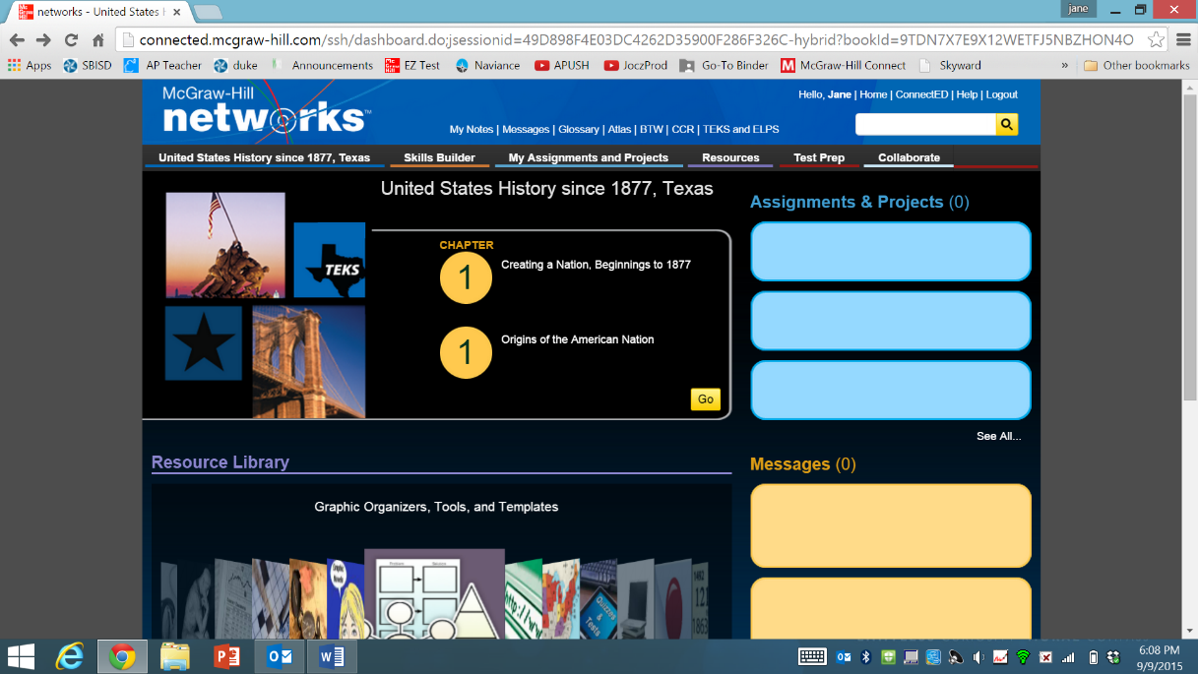

5. Using the pull down menu—Go to the correct chapter
6. Using the pull down menu—Go to the
correct lesson
7. Start reading the textbook.

